March 11, 2024 Do You Know NMO ?

[FULL NAME]
[ADDRESS]

Dear [TITLE] [LAST NAME],

I am writing to thank you on behalf of patients facing Neuromyelitis optica (NMO)—a rare and devastating autoimmune disease that can cause blindness and paralysis—or worse. For over 100 years, there had been no clinical trials and no FDA-approved therapies for NMO. That story changed in 2008 when The Guthy-Jackson Charitable Foundation (GJCF) began its mission for cures. The GJCF is the recognized and trusted leader in accelerating innovative research, enabling clinical advances and promoting patient advocacy around the world. In large part due to the GJCF funding of $80M over just 15 years, today there are three FDA-approved therapies that can save and improve lives of patients with of NMO.

However, no approved therapies will help if patients cannot access them.

We need your help to address this challenge together. Here are some key issues:

- Insurance companies often require patients to have potentially catastrophic relapse(s) on a non-approved therapy before they will pay for an FDA-approved therapy.

- NMO and like autoimmune diseases often prevent otherwise highly capable people from working full time or at all—in turn can they lose their income and their health insurance.

- NMO and most autoimmune diseases more commonly afflict women—and often in the prime of life when children, families and careers need them most.

- NMO disproportionately afflicts underserved populations, who often go undiagnosed or misdiagnosed—leading to suboptimal healthcare and more severe outcomes.

GJCF would greatly appreciate your help to improve access to FDA-approved therapies for patients with NMO. Will you please join us in an upcoming GJCF Town Hall Webinar ?

Once again, thank you for helping advocates like me help patients facing NMO.

Please watch Behind the Mystery: Neuromyelitis Optica.

Respectfully, Cureageous.®
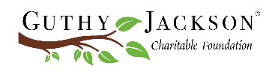
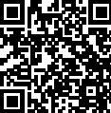
[YOUR NAME] — NMO Advocate

